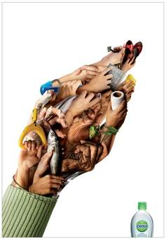
Hand sanitizer policy
We are proactive in our fight against germs so that your child will stay healthy! The children wash their hands with soap and water after they use the restroom, prior to eating, and when their hands are dirty. We would like to be able to use hand sanitizer during those in-between times such as when your child arrives for child care/preschool, after a sneeze or after gross motor play. We use an alcohol free, foam sanitizer. Please sign below to give us permission to keep all children healthy!

_________________________________________ ______________
Parent’s Signature Date

Hand sanitizer policy
We are proactive in our fight against germs so that your child will stay healthy! The children wash their hands with soap and water after they use the restroom, prior to eating, and when their hands are dirty. We would like to be able to use hand sanitizer during those in-between times such as when your child arrives for child care/preschool, after a sneeze or after gross motor play. We use an alcohol free, foam sanitizer. Please sign below to give us permission to keep all children healthy!

_________________________________________ ______________
Parent’s Signature Date

